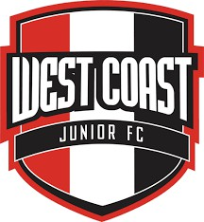

West Coast Junior Football Club
Sponsorship Prospectus 2026

President’s Message
West Coast Junior Football Club (WCJFC) is proud to invite you to partner with us as a Club sponsor in 2026. Based at City Beach Oval, WCJFC supports more than 400 local families, offering junior football pathways from Auskick through to Year 12 in a positive, inclusive community environment.

As part of the Claremont District, we are committed to player development, quality coaching, and strong club culture. Like all community clubs, we rely on the support of local businesses to keep football accessible and affordable. Your sponsorship provides valuable exposure while directly supporting grassroots junior sport.

We would be delighted to welcome you as part of the WCJFC community in 2026 and beyond.

Andrew Thomson
President
West Coast Junior Football Club
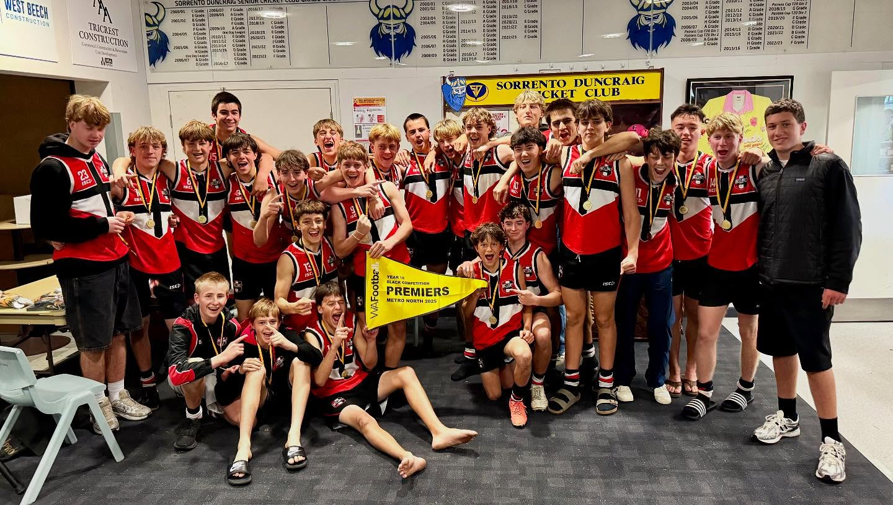


Sponsorship Opportunities

Community Sponsor – $500 (Donation)
A donation-based sponsorship ideal for local businesses, families, and individuals wishing to support grassroots junior football.

Benefits include:
- Recognition as a WCJFC Community Sponsor
- Promotion in club mailouts to families and members
- Acknowledgement across WCJFC social media channels

Perfect for small local businesses, families, and community members who want to give back.

Club Sponsor – $1,500
Benefits include:
- Tear-drop signage at home games
- Club jumper and certificate of appreciation
- Recognition on Sponsors Board
- Promotion at Auskick Gala Day
- Logo placement across newsletters, website, and social media

Major Sponsor – $5,000 (3-year commitment)
Benefits include:
- Exclusive Major Sponsor recognition
- Logo placement on club jumpers
- Banner signage at City Beach Oval
- Prominent Sponsors Board signage
- Promotion across all WCJFC platforms

Contact

Jacinta Pickford
Sponsorship Coordinator
Email: 0433 954 603
jacinta.pickford@gmail.com

